**CENG 206 Project 2 – Hide-and-seek Game**

**Group 9**

Project Group Participants:

* Beyza Nur Deliktaş 21050111008
* İrem Şahar 21050141024
* Osmancan Çağlayan 21050111074

1. **Inheritance**

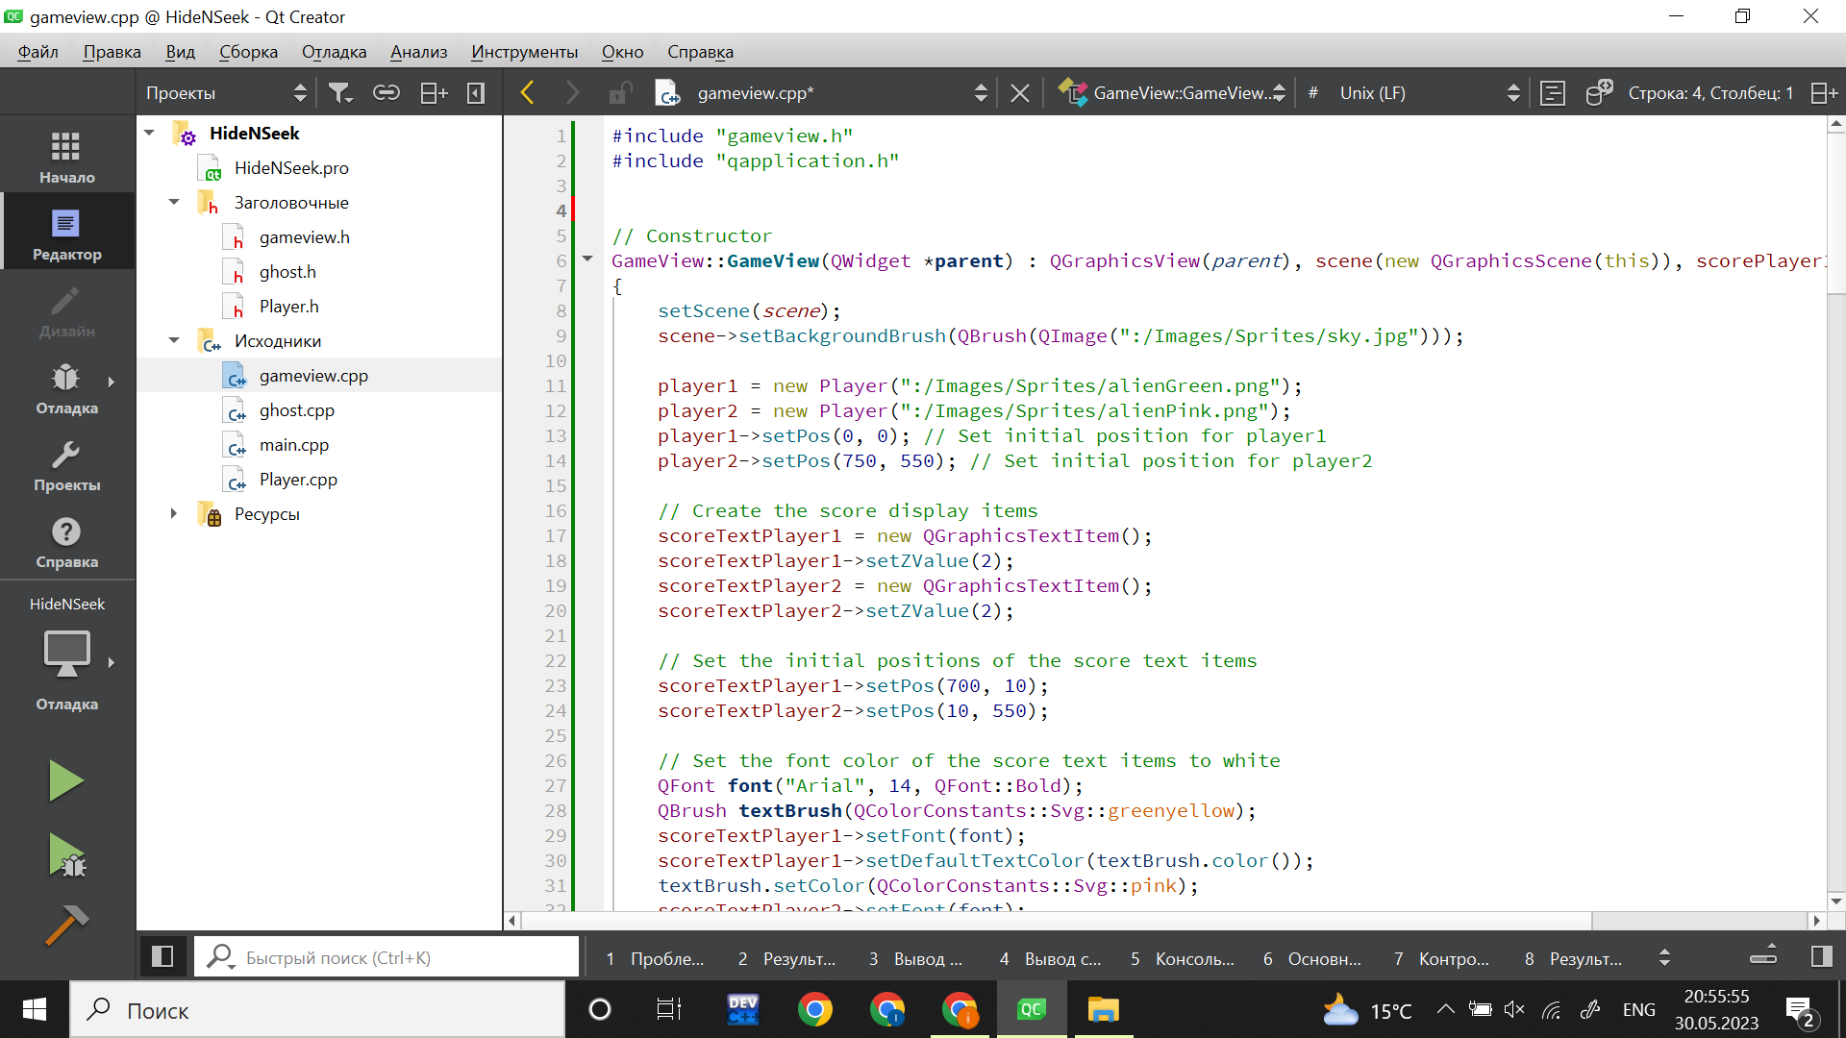

**b. Exception handling**

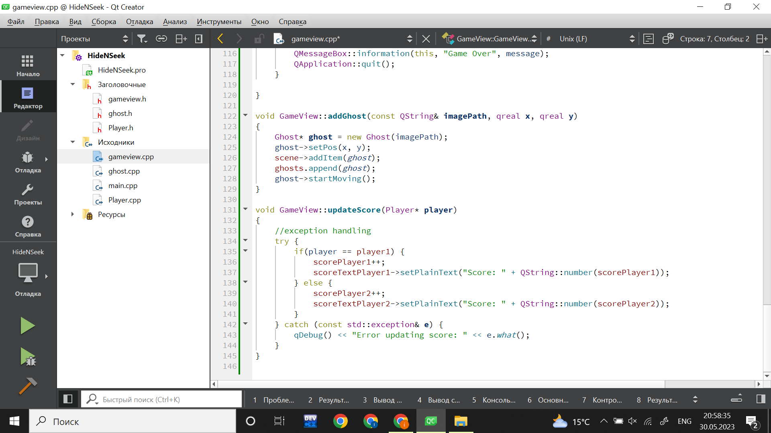

**c. Default parameter**

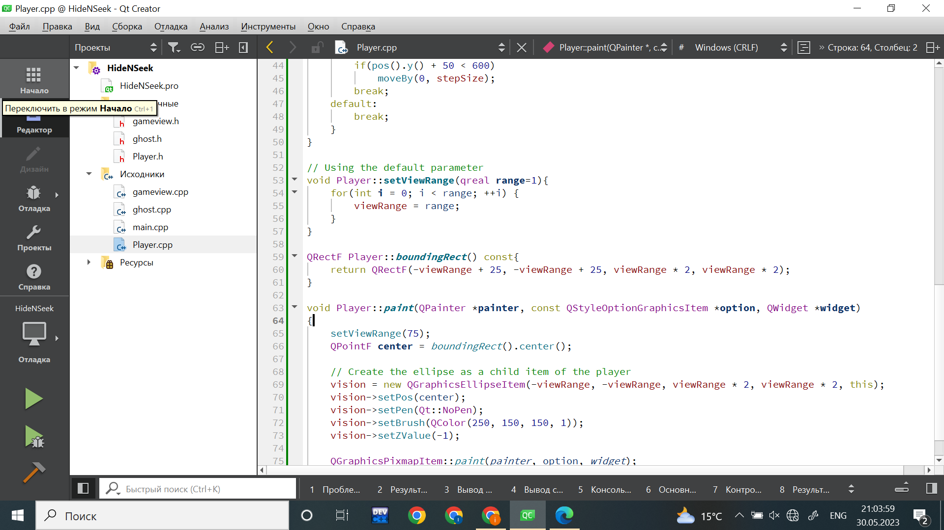

**d. Operator overloading**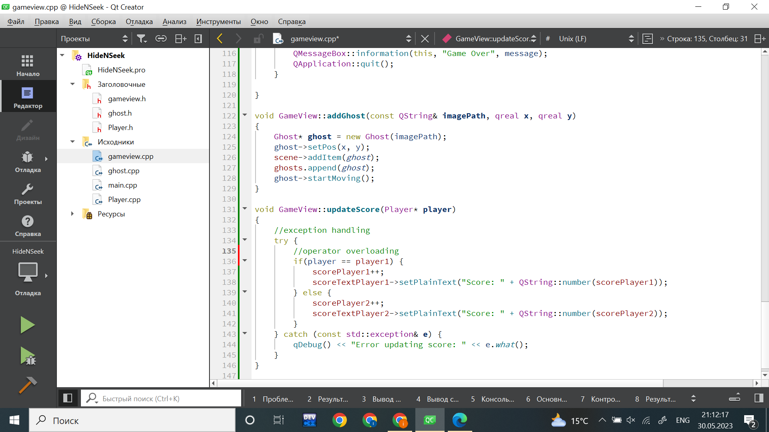

**e. Inline function**

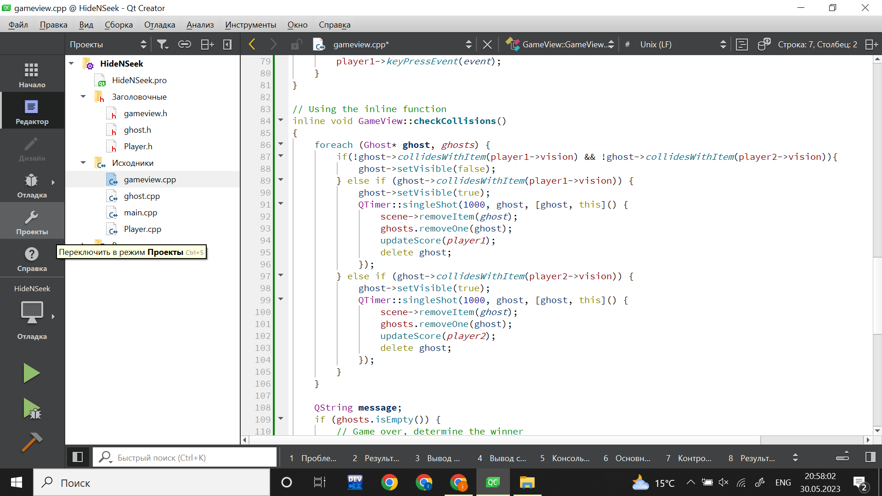

**f. Constructor/destructor**

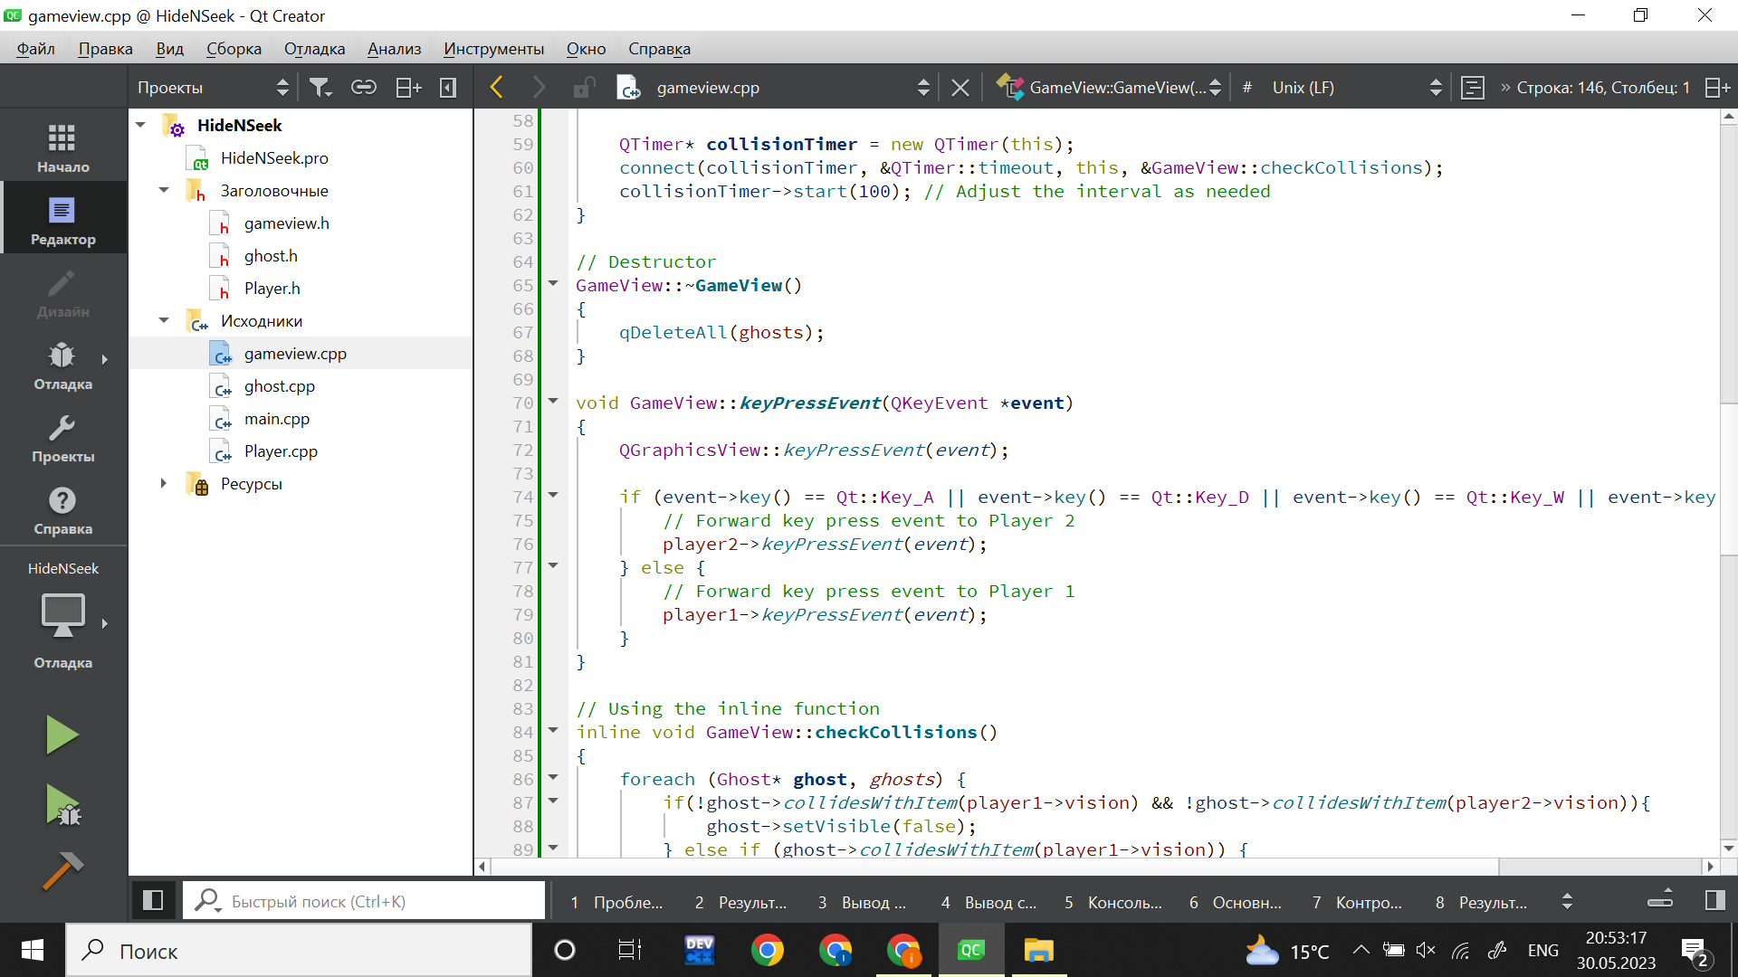



**g. Vectors**

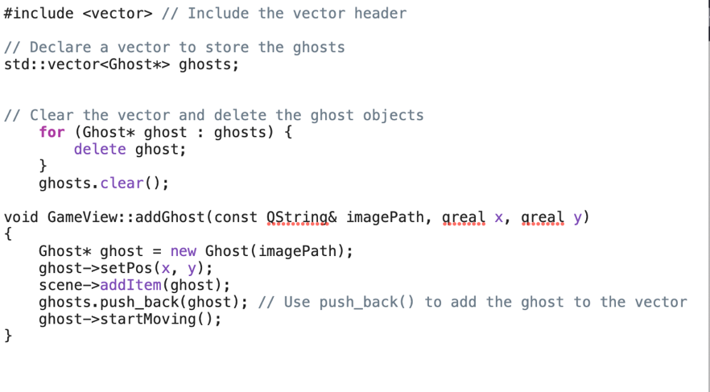

**h. Explicit heap dynamic variable**

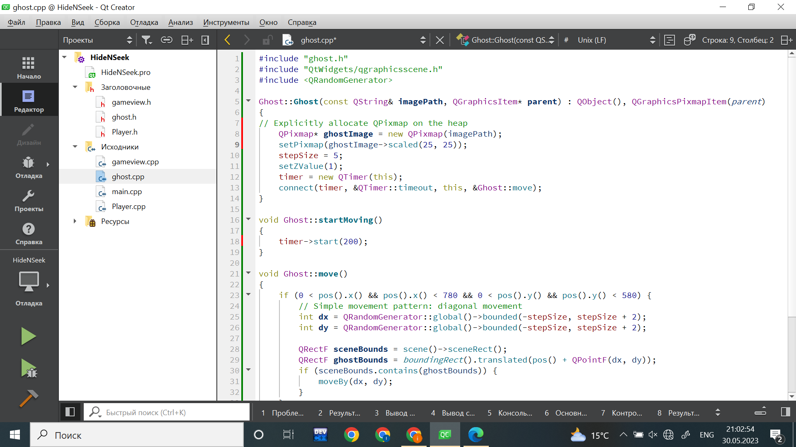

**Screenshots of the Game**

As mentioned in the presentation and on github, there are 2 versions of our game (the code for each version is available on github, also the gameplay video of version 2 is available too). However, in the 2nd version, since the problem of not opening on some computers was encountered, we presented the safer one as the main game in our project.

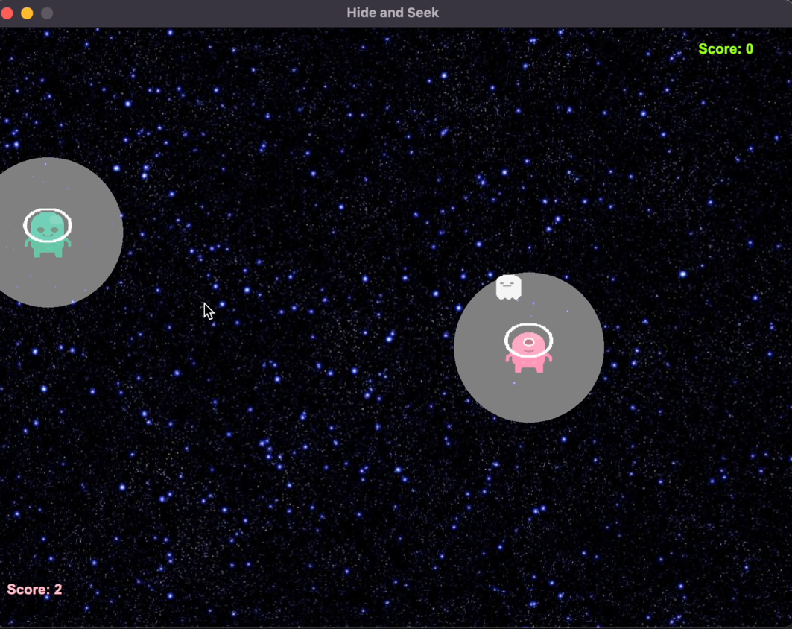

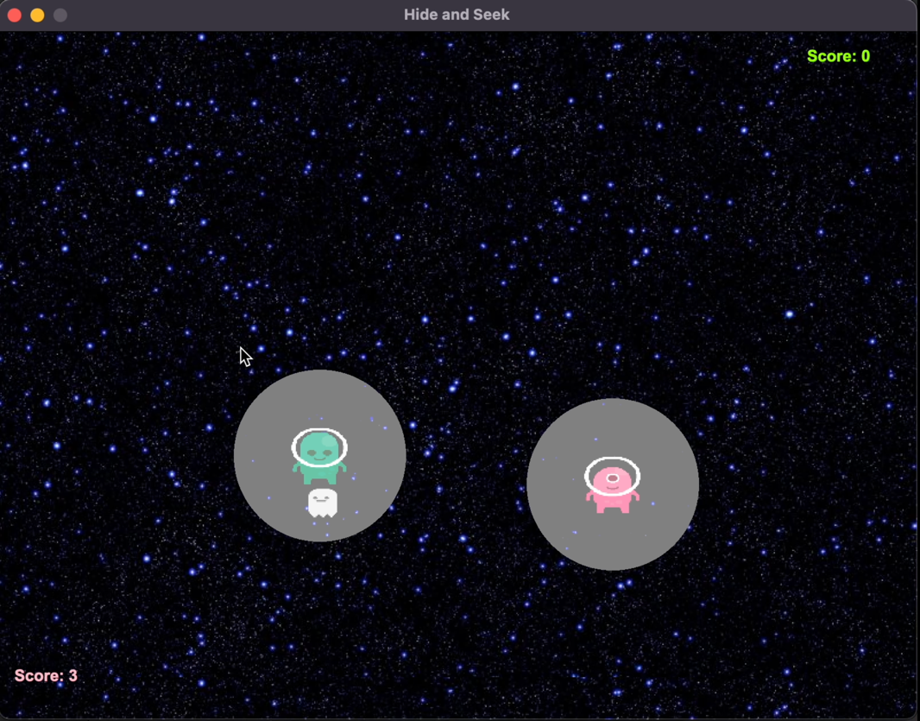

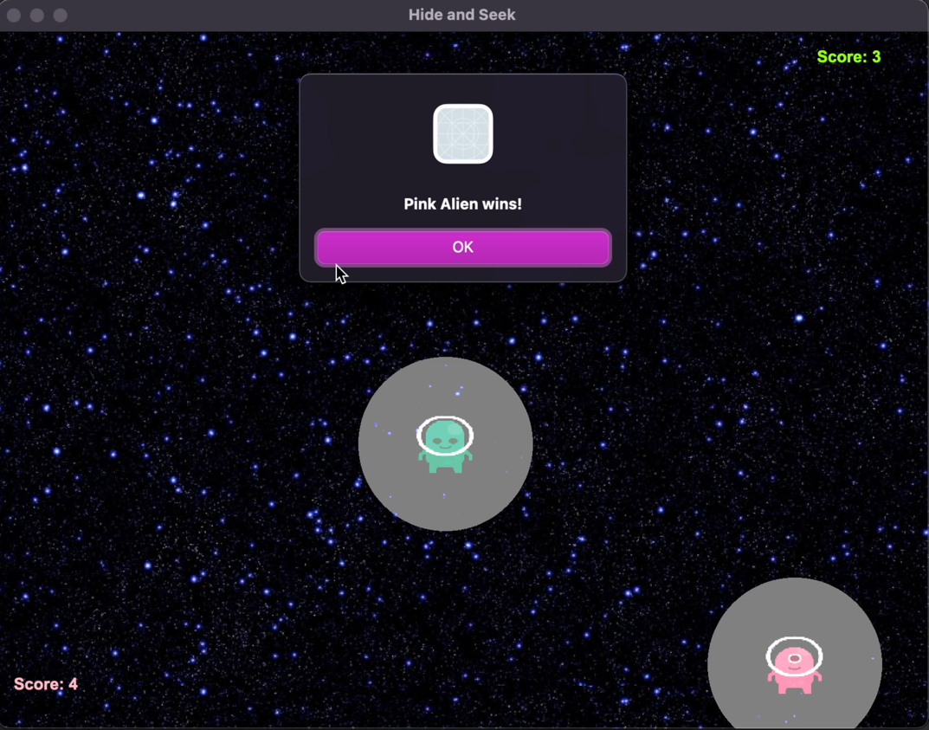

In version 2, there is a game with 2 rounds and a timer. The player who catches the most ghosts during the time is the winner.

